**Our Ballroom & Garden Rent at The Same Price!**

So, Whether You Want to Have Your Upcoming Event in Our Elegant-Grand Ballroom or in a Nature Setting, You Get to Choose and Not Have to Worry About the Varying Prices.

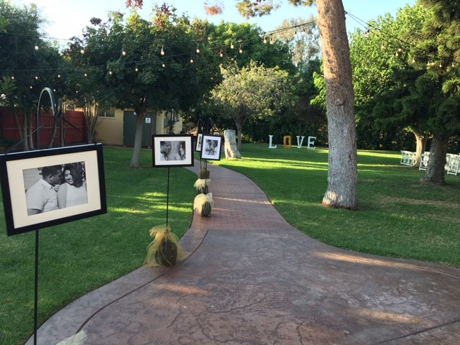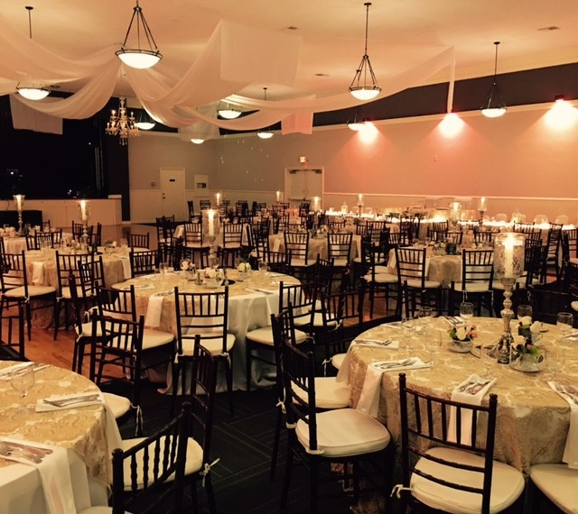

We create custom packages for every individual event we do.

Contact us to get a quote for your event!